

**Digital Design System Project Report**

Name : 1) Muhammad Hafizuddin Bin Redzuan (B17MJ0015)

2) Muhammad Aris Bin Adnan (B17MJ0013)

3) Mohamad Afnan Ilham Bin Abdul Rahman (B17MJ0009)

Section : 01

Lecturer : Pn Nordinah Binti Ismail

**Introduction On System**

The system that our team create is a type of game, which we got the inspiration from the game hangman. Instead of guessing the words user need to guess the number which is randomly generate from the program. The random number is generated by using CLOCK. Whenever the user is ready to play the game, user have to press a button (negedge) to START the game and the clock will run and stop after the user release the button (posedge) and that is how the number is being generated. After that, the user is given 3 chances to guess the correct number. The user have to choose which number they want to pick by toggling the switch SW15 to SW0 (The number of the switch represent the chosen number). If the user pick the correct number, 7 segment will display ‘WIN’. Whereas if the user fail to guess the number 3 times, the 7 segment will display ‘LOSE’.

**Problem Statement**

The game is design to be an easy to play game, which doesn’t involve a lot of thinking but require sharp instinct. Even though the game is quite simple but it is still fun to play. This game can be played by user regardless of their age. It is a game that can relieve stress and make the user forget about their daily problem. User will become eager to guess the correct number until they achieve victory. This game can be played with family and friend, where it can strengthen the bond between them. This is the kind of game that is lack from today society.

**Theory/ Background**

The background of the system that we use in this program is the combination of several state.

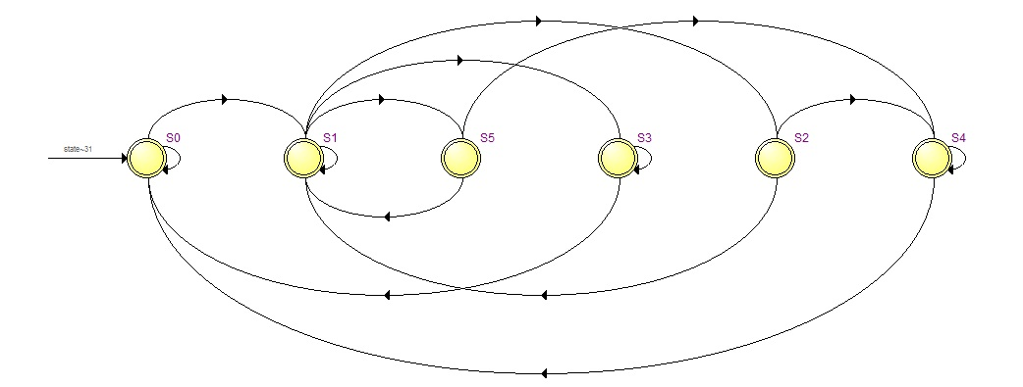

**Legend:**

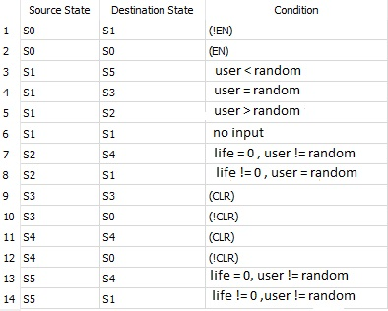

**S0**

S0 is the initial state. If user press enable, the state will proceed to S1. If not it will remain at S0.

**S1**

S1 is a comparator. If user guess less than the random number the state will change to S5, if user guess greater than random generate number the next state will be S2. If the user guess correctly the state will become S3 and if no input it will remain at the same state.

**S2**

S2 is ‘greater than’ state. If the user have life remaining, the state will return to S1 for another try. And when life is equal to 0 the state will proceed to S4.

**S3**

S3 is the Winning state. In this state 7 segment will display “WIN”. If user press clear it will go back to the initial state which is S0. If not the state will remain the same.

**S4**

S4 is the Losing State. In this state 7 segment will display “LOSE”. If user press clear it will go back to the initial state which is S0. If not the state will remain the same.

**S5**

S5 is ‘less than’ state. If the user have life remaining, the state will return to S1 for another try. And when life is equal to 0 the state will proceed to S4.

**Experimental Result**

As the result, this project is positive. Our team able to run project as we planned. The random number generated according to plan as we press the Push button, the random number starting to generate. The number display on 7 segment follow the number of toggle switch which is on. When the number of the generated number is higher than the number that were chosen, the ‘>’ symbol will be displayed on the 7 segment. In the contrary, when the number of the generated number is lower than the chosen number, the ‘<’ symbol will be displayed. The LEDG which represent as the life of the player will be deducted when user guess the wrong number. The user will be given 3 lives and when the lives reach 0 due to wrong guesses, ‘LOSE’ will be displayed on the 7 segment whereas the user will achieve victory when they guess the correct answer and ‘WIN’ will be displayed.

**Discussion**

The result that our team get from this project is the same as we planned at the beginning of the project where the number being generate by using clock. Then, the switch which is used by user to select the number also work as desired. So does the indicator that show whether the user win or lose. The major problem that were face by us is mainly when we trying to merge the sub module into a single module and also when we create the life tries module as we desired. In future, we think improvements that need to be made to improve this project is by adding timer into the game for making it more challenging by seeing who can guess the number fastest. We also thought to add PvP (Player Vs Player) to make the game more challenging and competitive.

**Conclusion**

As the conclusion, we think that this project is a success because we manage to apply the knowledge of Verilog coding throughout the semester to produce great and exciting games. Our team manage to complete the project in time. Although there are a lot problem that are faced by us, but still we managed to endure all obstacle as a group. Lastly, we want to show that using Verilog coding can also produce an interesting game to play.